Requirements for this paper:
 | Multi choice cards: |  | Programmable calculator: |  |  |  |  |  | Open book examination
 | Graphic paper: |  | Laptop:
EKSAMEN/  EXAMINATION: |  |  |  | Semestertoets 1 Semester test 1 | kwalifikasieprogram/  /QUALIFICATION program:
modulekode/  Module CODE: |  |  |  | EERI 423 |  |  |  |  | duur/  duration: |  | 1 uur / 1 hour
module beskrywing/ module description: |  |  |  | Telekommunikasie / Telecommunication |  |  |  |  | maks / max:
EKSAMINATOR(E)/  examiner(s): |  |  |  | Prof J.E.W. Holm |  |  |  |  | datum /  date: |  | 2015-08-07
 |  |  |  |  |  |  |  |  | tyd / time: |  | 08:00
moderator: |  |  |  | Mr C.J. vd Merwe

Totaal / TOTAL: 50

Vraag 1 / Question 1 - [15]
A) Definieer (i) basisband en (ii) breëband kommunikasie. / Define (i) baseband and (ii) broadband communication. [4]

Baseband is found before a signal is modulated (thus unmodulated data or voice) before the signal is sent across a medium [2].

Wideband communication is usually after a signal has been modulated and usually refers to the signal that is transmitted across a medium [2].

B) Verduidelik die verskil tussen simpleks en vol-dupleks kommunikasie. / Explain the difference between simplex and full-duplex communication. [2]
1) Simplex - Communication in one direction only [1]
2) Full-duplex - Communication in both directions simultaneously [1]

Vraag 2 / Question 2 - [16]
C) ‘n Versterker versterk 10 mW na 100 W. Wat is die wins in dB? / An amplifier amplifies 10 mW to 100 W. What is the gain in dB? [2]
Answer:
Ap = 100 / 10E-3 = 1E4 -> 10 log (Ap) = 40 dB [2]

D) ‘n Spanningsversterker het ‘n wins van 100 dB. As die insetsein 1 mV is, wat is die uitset in Volt? / A voltage amplifier has a gain of 100 dB. If the input signal is 1 mV, what is the output in Volt? [2]
Answer:
Gain = 10(100/20) = 100 000 -> Output = 100 V [2]

E) Verduidelik kortliks: (i) invoegverlies en (ii) vormfaktor / Briefly explain (i) insertion loss and (ii) shape factor. [3]
1) Insertion loss is the attenuation that a filter gives in the passband [1]
2) Shape factor is the ratio of stop-band [1] to pass-band bandwidths [1], e.g BW_{-60dB}/BW_{-6dB}.

D) ‘n Ontvanger het die volgende drywingswinselemente / A receiver has the following power gain elements:

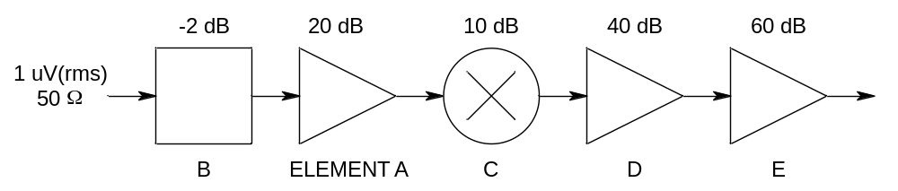

- Gee die totale wins van die ontvanger / Give the total gain of the receiver; [2]
- Bereken die uitsetdrywing in dBm / Compute the output power in dBm; [2]
- Wat sal die spanning wees oor ‘n 1 kΩ las / What will the voltage be across a 1 kΩ load? [2]

Totale wins = -2 + 20 + 10 + 40 + 60 = 128 dB [2]
Insetdrywing = 10 log (1E-6^2 / 50 * 1000) = -107 dBm [2]
Uitsetdrywing = -107 + 128 = 21 dBm -> Puit = 10^(21/10) = 125.9mW -> Vuit ≈ 11V [2]

Vraag 3 / Question 3 - []
A) Noem die 4 basiese tipes pulsmodulasie. / Name the 4 basic types of pulse modulation. [4]
1) Pulse amplitude [1]
2) Pulse position [1]
3) Pulse-width [1]
4) Pulse-code modulation [1]
B) Verduidelik die beginsel van werking van ‘n “compander” met verwysing na spraakseine. / Explain the principle of operation of a compander with reference to voice signals. [3]
Compander principle of operation (any three below)
Voice has the most information at low signal levels
Therefore, companders amplify low-level signals and compress high-level signals
Digitization noise is minimised as the low level voice signals are amplified before digitization
Noise is most prevalent at low levels, so this amplification improves signal-to-noise

C) ‘n μ-Wet omsetter (“compander”) met ‘n maksimum waarde van 1 V en ‘n μ-waarde van 255 ontvang ‘n sein van 100 mV. Wat is die uitsetspanning en die spanningswins? / A μ-Law compander with a maximum value of 1 V and a μ value of 255 receives a signal of 100 mV. What is the output voltage and voltage gain? [4]
Companders
μ | 255
Vin | 100 | mV
Vm | 1 | V
Vout | 0.59 | V | [2] |  |  | 2
Gain | 5.9 or | 15.4dB | [2] |  |  | 2

D) Teken die basiese elemente van ‘n tipiese lae-vlak FM versender (met indirekte FM) [4] en verduidelik elke element se funksie [4]. Jy hoef nie die antenne te noem of te beskryf nie. / Draw the basic elements of a typical low-level FM transmitter (with indirect FM) [4] and explain each element’s function [4]. You don’t have to name and describe the antenna.
Halwe punt vir elke feit...
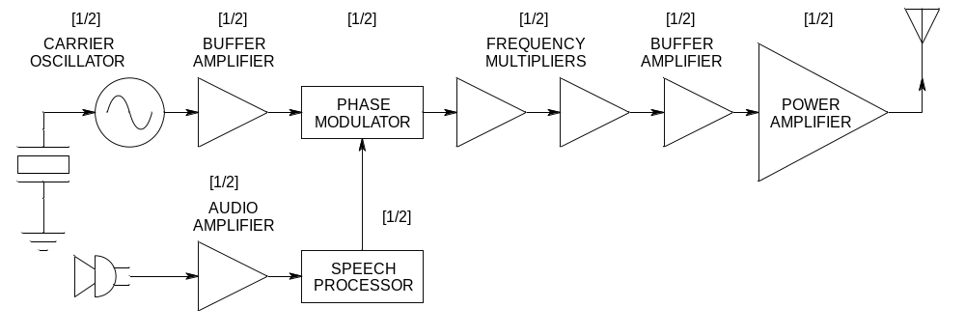

- Carrier oscillator – generates the carrier signal to be modulated [1/2]
- Buffer amplifier 1 – isolates the carrier oscillator (constant impedance) and provides gain [1/2]
- Phase modulator – performs indirect FM [1/2]
- Audio amplifier – amplifies intelligence signals [1/2]
- Speech processor – filters out high frequencies and processes speech for FM [1/2]
- Frequency multipliers – multiplies modulated carrier for RF transmission [1/2]
- Buffer amplifier 2 – provides adequate signal levels for power amplifier [1/2]
- Power amplifier – provides sufficient signal level for RF transmission [1/2

E) Teken die blokdiagram van ‘n fasesluitlus sintetiseerder met ‘n voorverdeler en ‘n programmeerbare frekwensie verdeler en benoem elke element duidelik op die diagram. / Draw the block diagram of a phase locked loop synthesizer with a prescaler and a programmable frequency divider and name each element clearly on the diagram. [6]
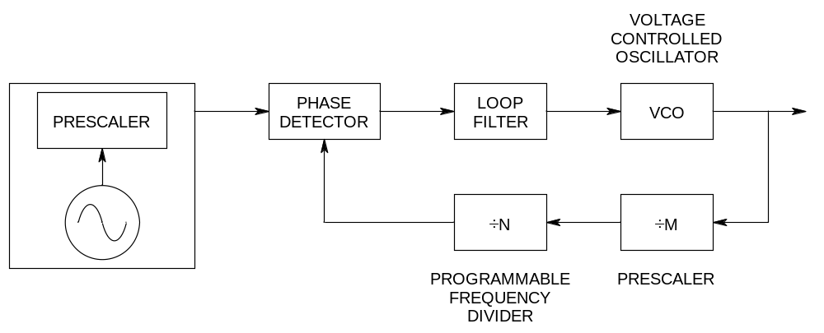
F) ‘n Sintetiseerder in (A) het ‘n konstant voorverdeler waarde van M = 32, ‘n programmeerbare verdeler waarde van N = 16, en ‘n verwysingsfrekwensie van f_{ref} = 100 kHz / The synthesizer in (A) has a constant prescaler value of M = 32, a programmable divider value of N = 16, and a reference frequency of f_{ref} = 100 kHz: [5]
1) Bereken die uitsetfrekwensie / Calculate the output frequency; [2]

f_{out} = M x N x f_{ref} = 51.2 MHz

2) Wat is die frekwensie-inkremente (resolusie)? / What are the frequency increments (resolution)? [2]

Resolution = 100kHz x M = 3.2 MHz
Can also be calculated by incrementing N (NOT M, this would be wrong) and then calcuating frequencies at both N = 16 and N = 17.

3) Wat kan in die terugvoerlus gebruik word om die resolusie te verbeter? / What can be used in the feedback loop to improve the resolution? [1]
- Fractional N divider [1]

